40.47: a) 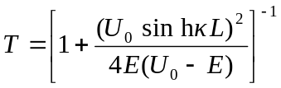
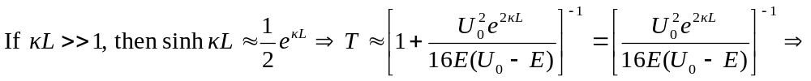
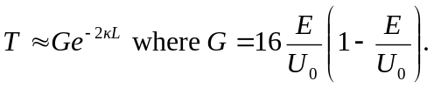
b) 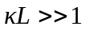 implies either is large or is large (or both are large). If
is large, the barrier is wide. If is large, 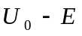 is big, which implies  is small compared to 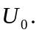
c) 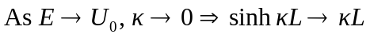
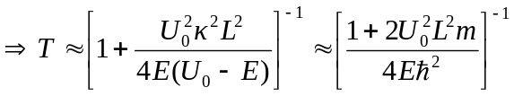
since 